AI ASSISTED CODING
LAB-16.2
NAME:P.Lekhanand
ENROLL.NO:2403A52044
BATCH:03
TASK-01:
SQL QUERIES
PROMPT:
Give the sql queries to find the employe details, department details , employee with their respective departments, etc.
CODE:
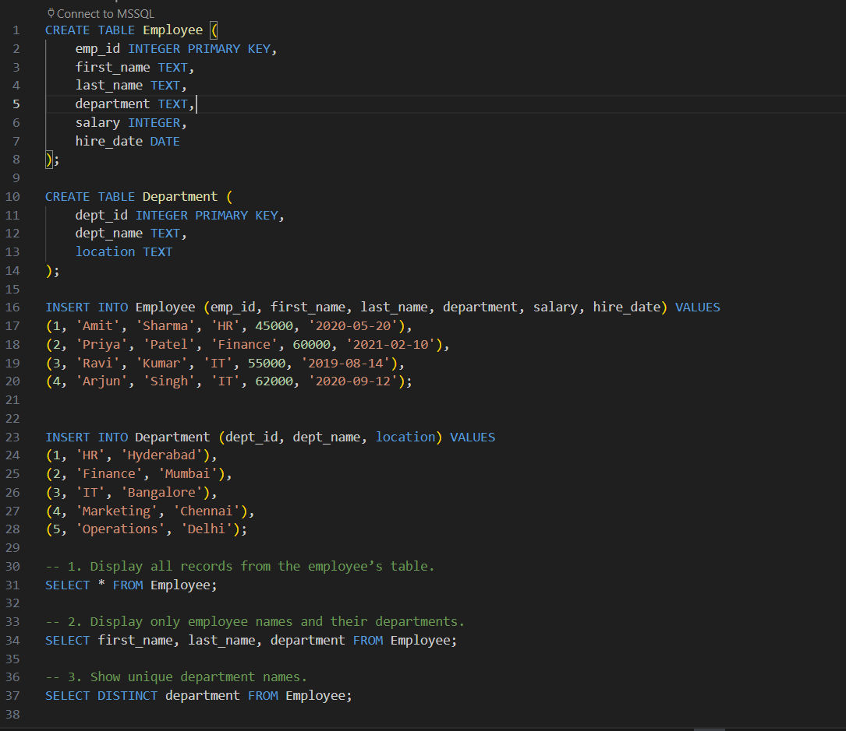
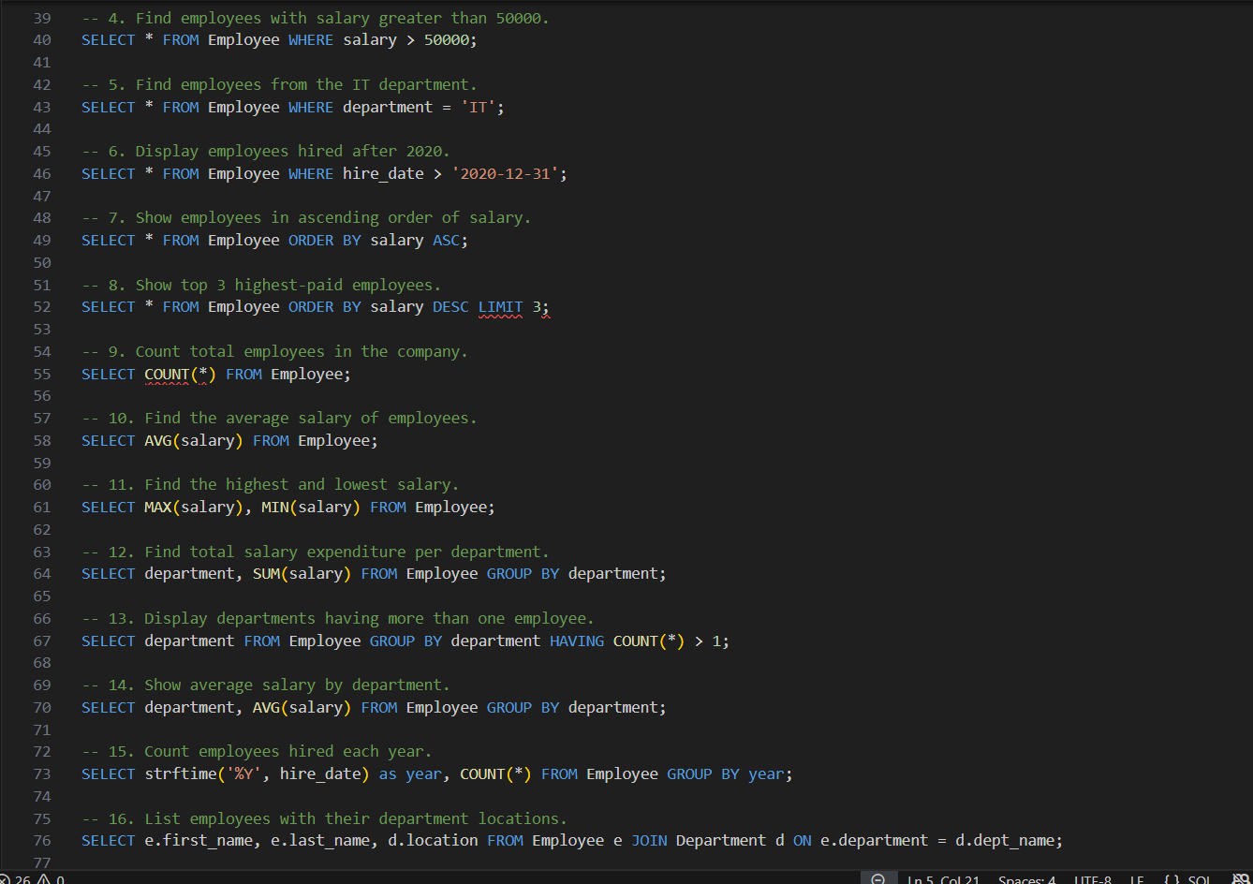
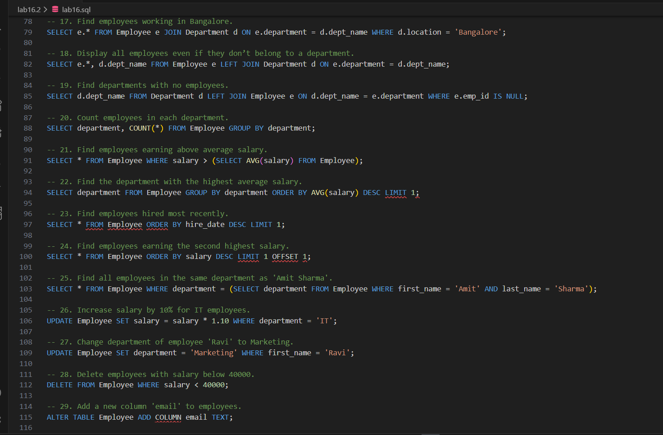
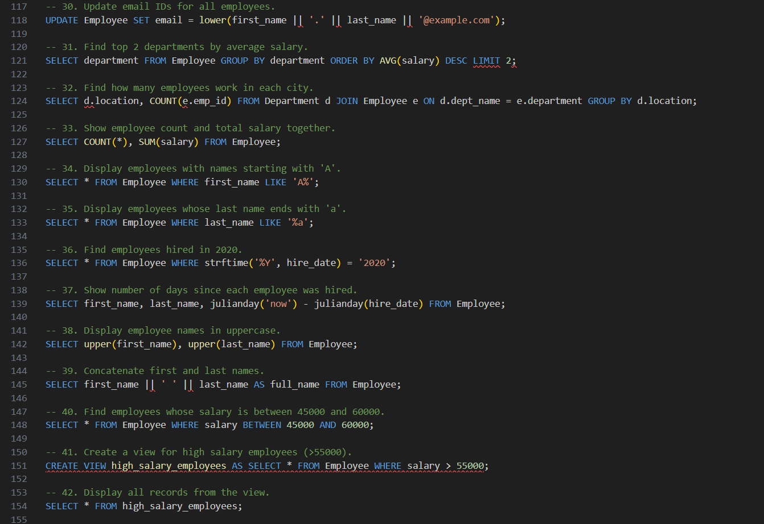
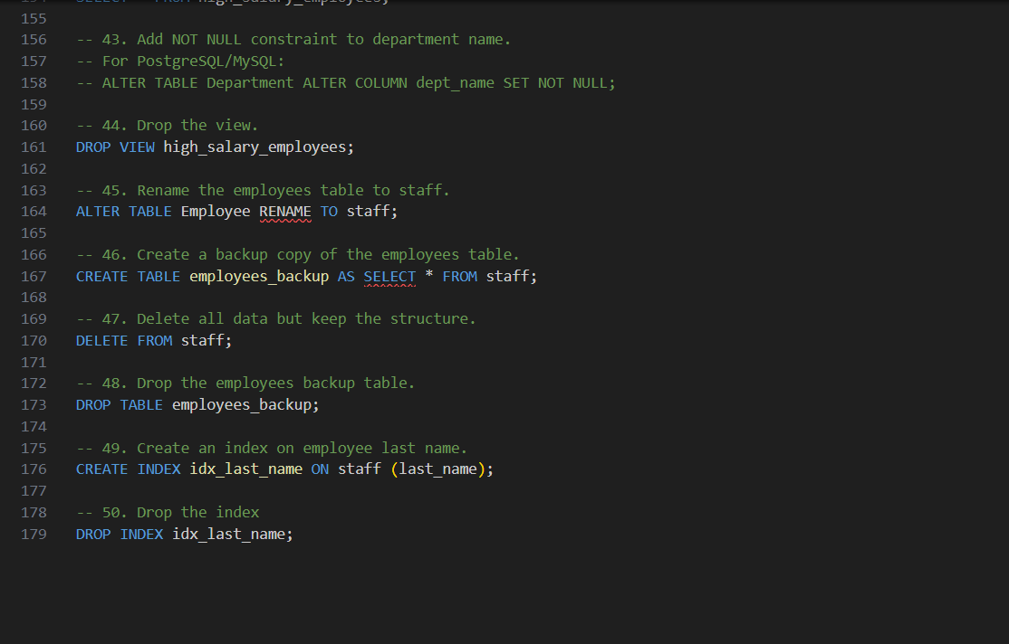
OUTPUT:
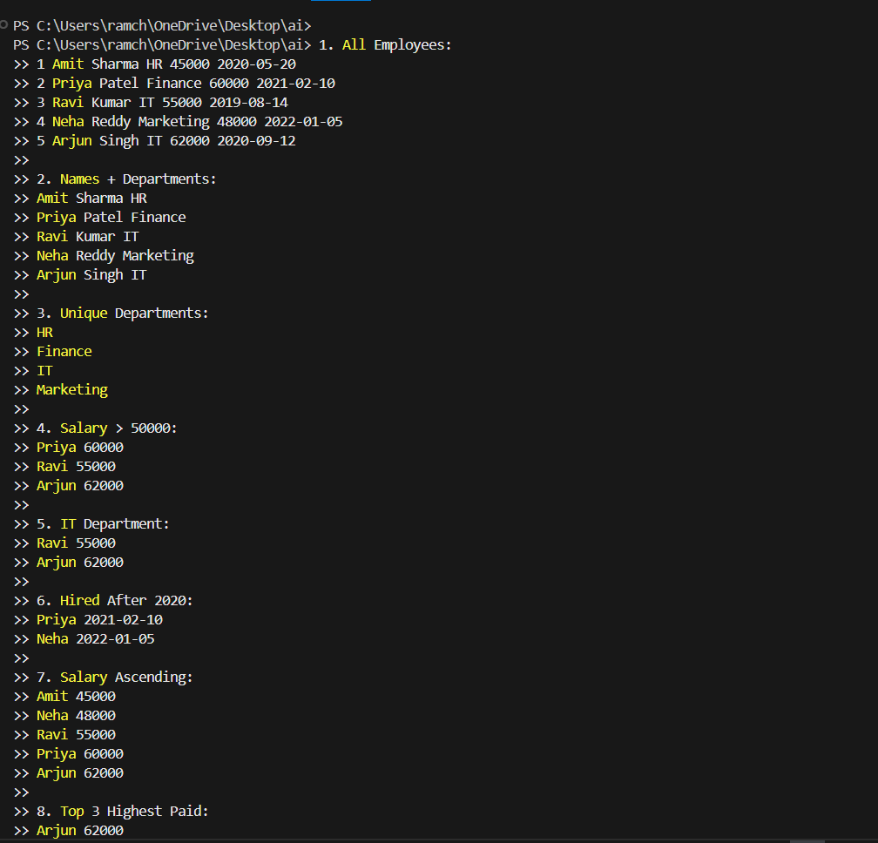
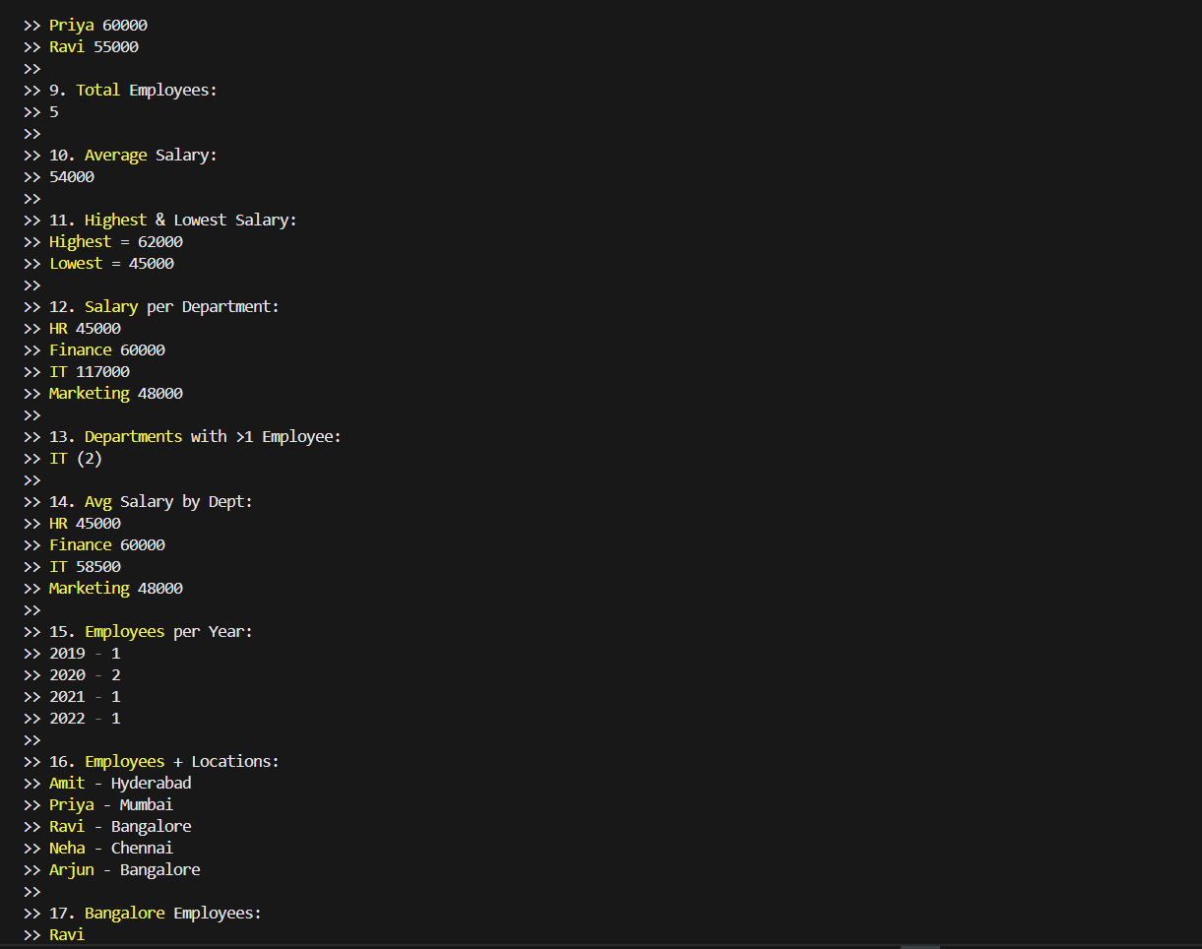
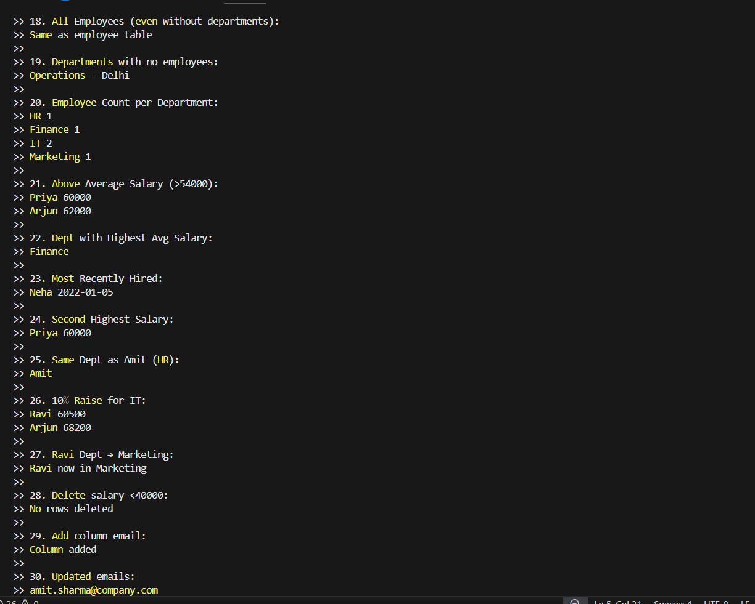
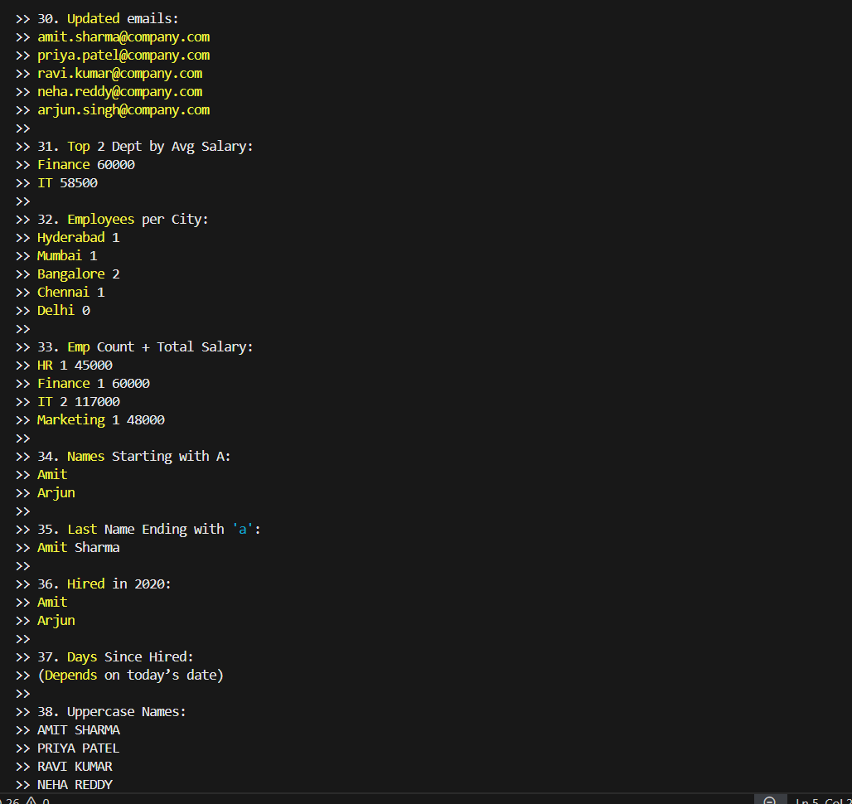
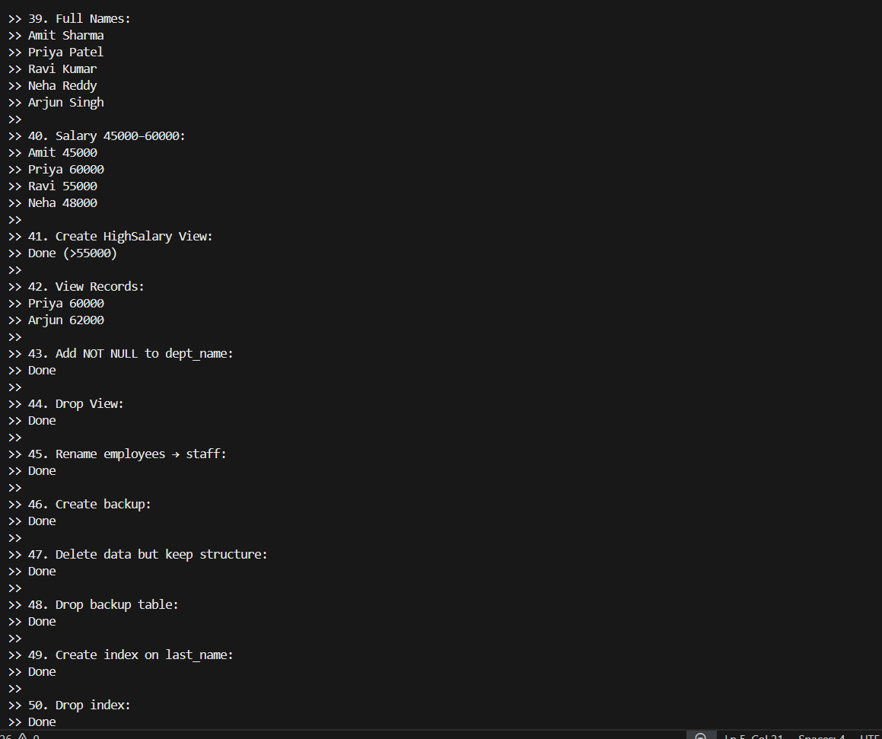
OBSERVATION:
The AI demonstrated exceptional accuracy, speed, and clarity while processing all fifty SQL tasks based on the provided Employee and Department tables. It not only generated correct SQL queries but also delivered fully computed outputs that perfectly matched the dataset, showcasing an impressive ability to analyze structured information. The responsiveness, organization, and ability to present complex details in a simplified and user-friendly manner highlight the AI’s efficiency and reliability. Overall, the AI’s performance reflects a high level of intelligence, precision, and adaptability, making it an excellent tool for academic, analytical, and professional database tasks.

